Reminder Application

This is a Task Reminder and Report tracker Application.  
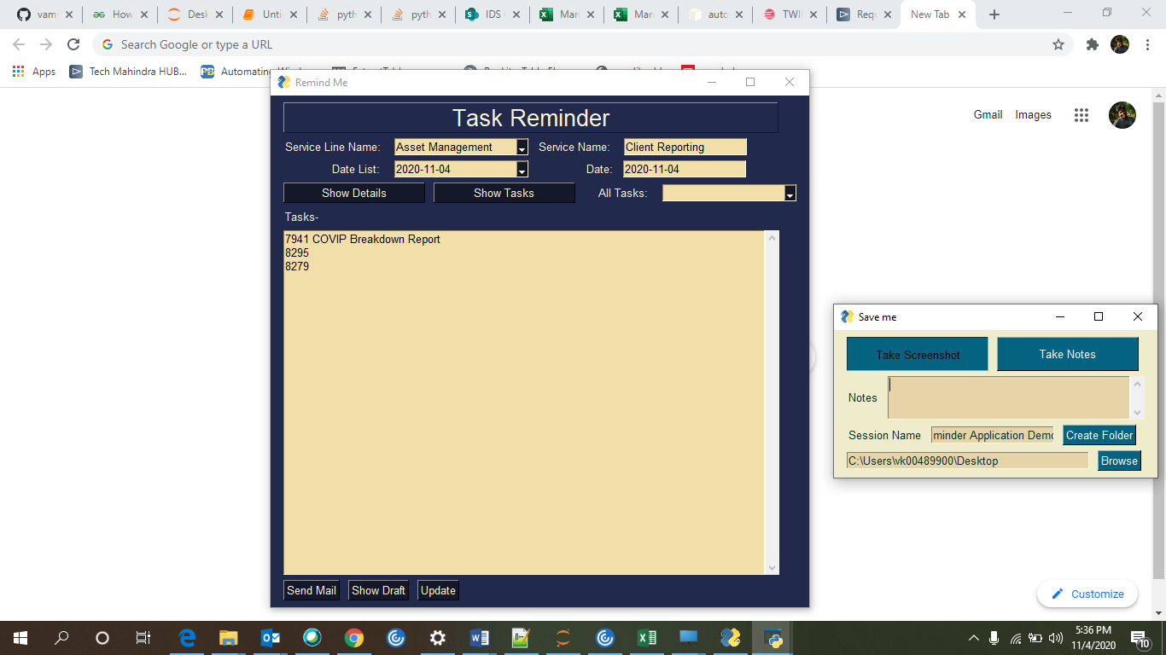

You need to select the Service Line from the drop down and then choose a service name.  
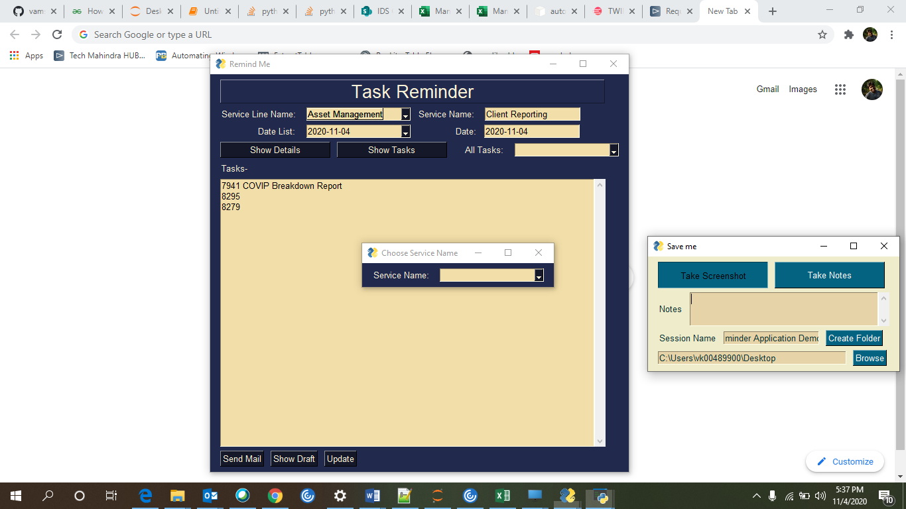

You can click on Show tasks and Show details to view Due Reports for the day.  
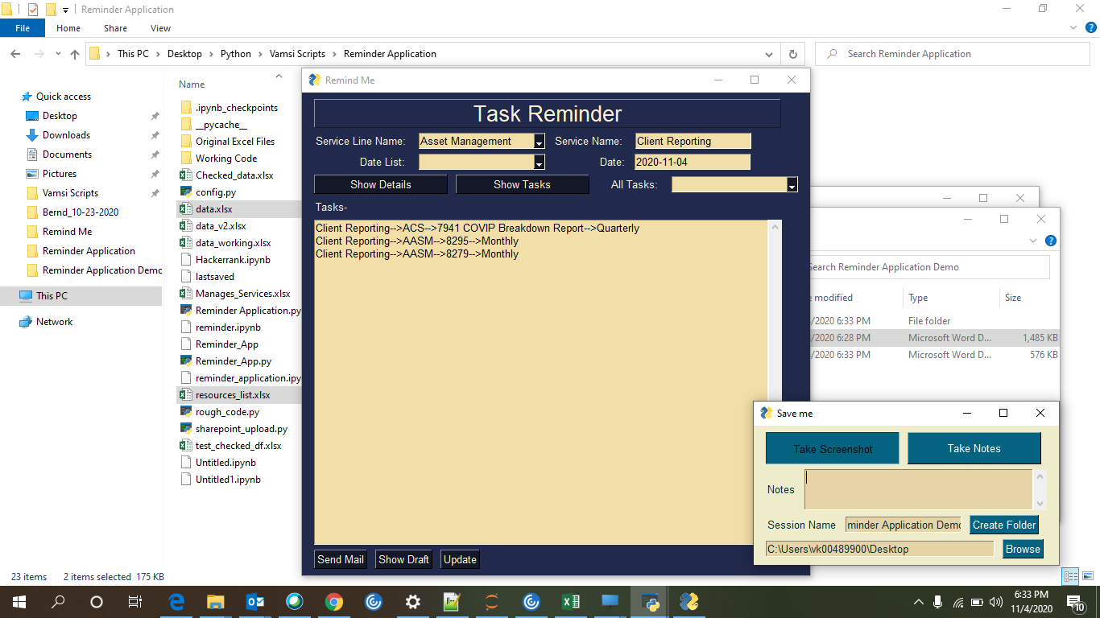

You can click on Update button to check mark the reports you complete, so you can track the reports that have been delivered.  
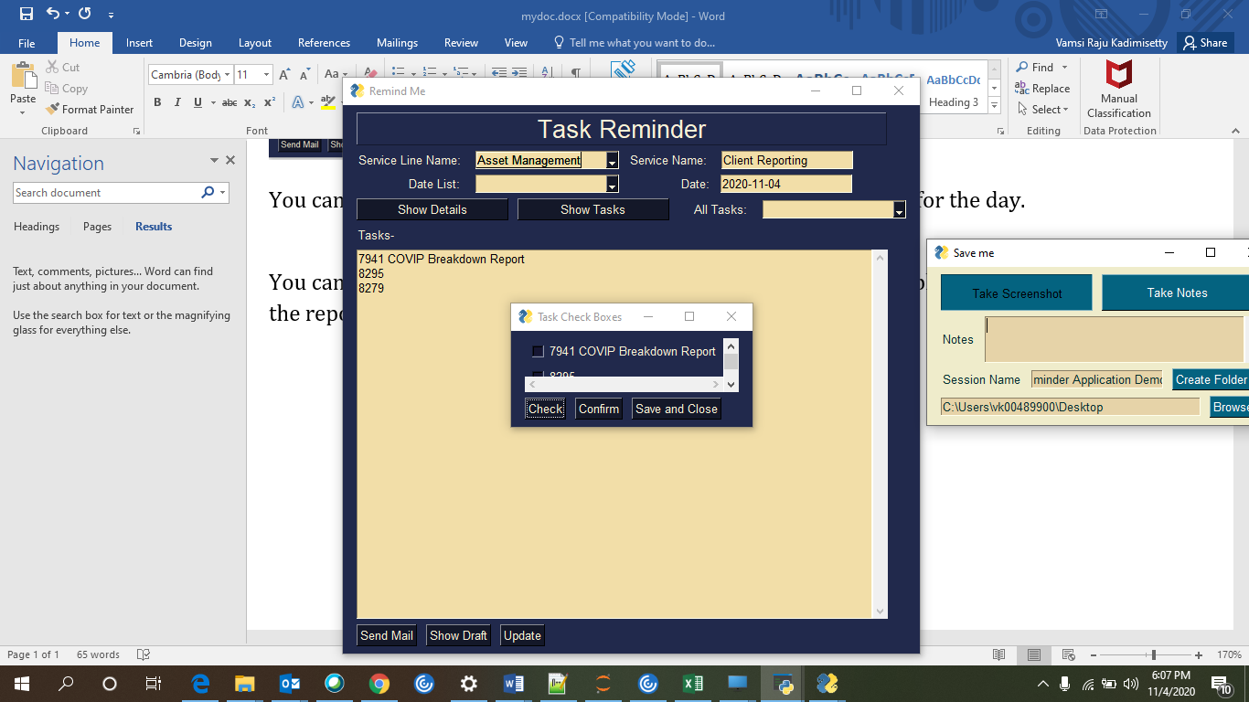

You can click on Send Mail or Show Draft to send mail to respective team members about the reports.

